The Ultimate How To Guide for Presenting Content in Microsoft Teams



Sharing / presenting content in Teams meeting is at the same time simple but is also has some options available that may not be known enough by everyone. This guide lets you get started and dive deeper what happens when you share your window, document or desktop in Microsoft Teams.

This article will be updated when there are new features or based on feedback.

Community: I am happy to add Mac and iOS screenshots into the article as well if someone is willing to collaborate & provide them.

Teams Desktop: sharing a screen (Windows)

Opening the sharing with Microsoft Teams Desktop (in the New Meeting experience mode).

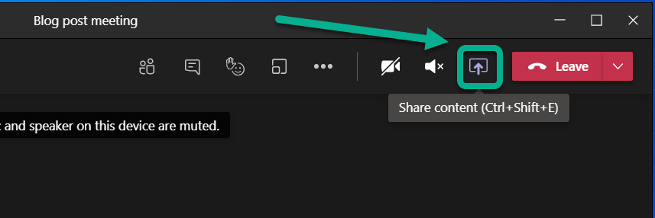

This opens the **Share Tray.**From it you can choose to start sharing

* Your Desktop (Screen share)
* Specific application (Window)
* Whiteboard application: either Microsoft Whiteboard (natively with Microsoft 365) or available 3rd party Whiteboards
* PowerPoint document

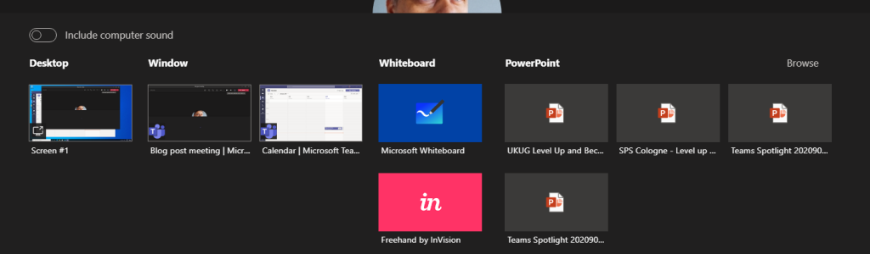

**TIP: When you choose to share something using Teams Desktop you can choose to include your computer sounds to meeting. This is a must-have option if you are playing music or video to your participants.***You can not toggle this on later – you need to choose this when you start sharing.*

When you choose to include computer sound included with the sharing you need to have configured the speaker for computer and Teams meeting to be the same one.

If you have multiple monitors available for your Microsoft Teams you can choose any of those displays.

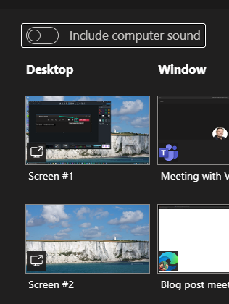

And you have the sharing open. Shared area is marked with red rectangle around it. You will find the more smaller Teams meeting control window in one of your desktops – and if you have the camera on it will show the video.

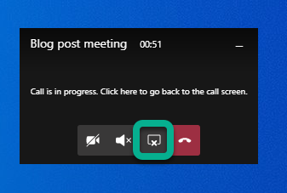

But more importantly you can use that small window to control camera, audio or sharing (ending it with one press). Or you can click on the small window (not on meeting toolbar) and it will expand back to the full size.

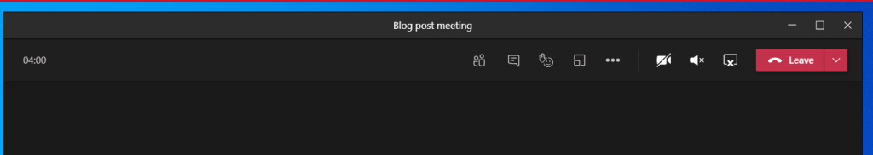

You can use that same icon to stop sharing in the expanded window.

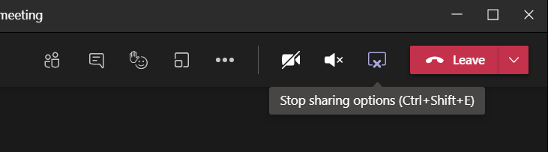

Tip: If you have two screens available you should consider presenting your PowerPoint presentation so that you share the external screen and project your presentation there (PowerPoint – Slide Show – Monitor). Share that external screen to Teams meeting so you can be sure that whatever you show in that screen it is shown to attendees. Just check that your second screen is not a ultra-wide display or 8k (or preferably even 4k) because the content is going to be tough to read and view by attendees. FullHD screen works the best here.

**Tip2: when you are presenting PowerPoint in external screen (and sharing that to Teams meeting) do they advantage of inking and pen if you are using a device with touch screen (like Surface)!**

Tip3: if you have an embedded video in your PowerPoint you have to use screen/display sharing to present it to the audience. Don’t forget include computer sound with your share!

Teams Desktop: sharing a PowerPoint

You can choose from your recent PowerPoint documents in the list

* A PowerPoint document you opened or edited in Microsoft Teams (in a team you belong to) or in your OneDrive
* Browse for more

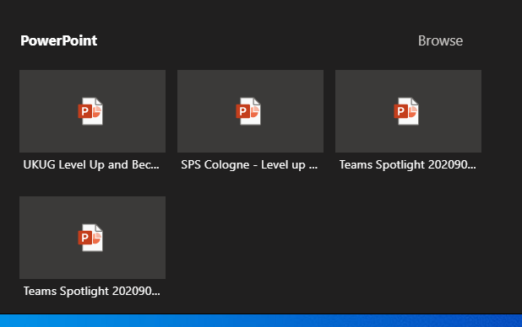

This list of sharing PowerPoints is causing often some big questions. PowerPoints will appear in the list once you edit or open the PowerPoint presentation in Teams or OneDrive (there may be some short delay). Generally it applies to the next meeting you join. Make sure you prepare for the meeting by opening the document in advance. Simply uploading a presentation to OneDrive or Teams does not bring it to the list – you need to open/edit it as well.

Browse-option lets you choose a PowerPoint from your OneDrive or from your computer.

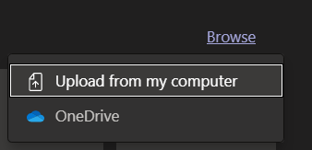

What this one lacks is the ability to choose a file from a team you belong to.

**TIP: Use OneDrive syncing to have an easy access to files in the most relevant teams you belong to**.

Once you are sharing the PowerPoint you can see it in the presenter view mode! **This feature was**[**just released to Public preview**](https://techcommunity.microsoft.com/t5/microsoft-teams-public-preview/now-in-public-preview-powerpoint-presenter-view-in-teams/m-p/2062591?WT.mc_id=M365-MVP-5003326)! This makes it easy to do presentations using Teams – without having to have a PowerPoint desktop app open at the same time. Seems to work only on Teams Desktop with new meeting experience mode at the moment (and you have to be in the Public Preview).

The presented area (PowerPoint) is shown surrounded with a red rectangle.

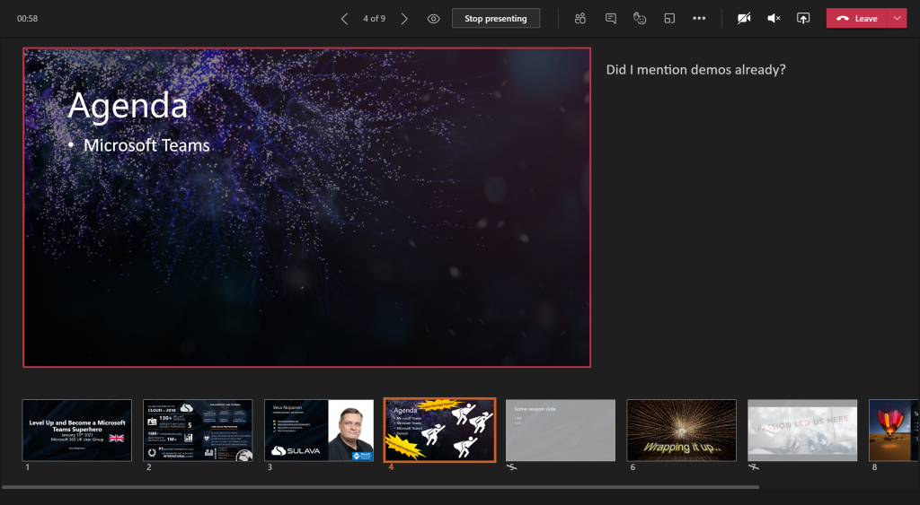

Once the presentation is shared you can move back and forth easily with arrows in the screen.

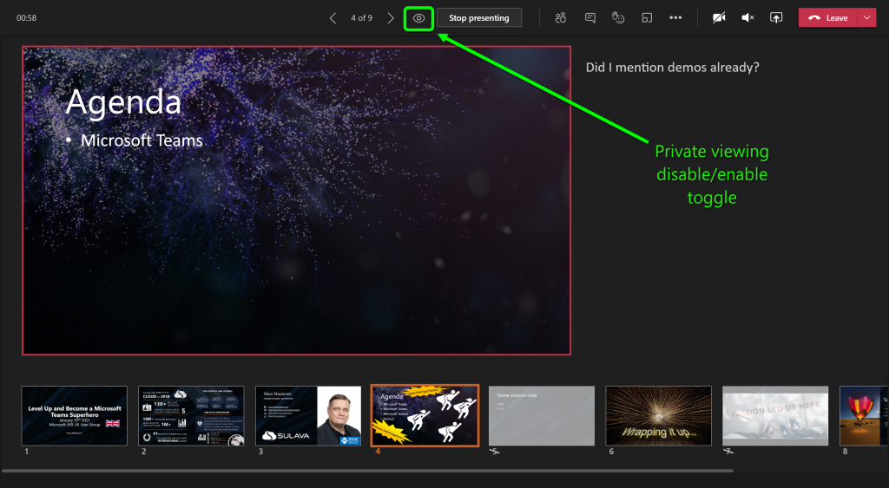

Note: there is the “eye” icon. If you press that one it locks the PowerPoint for the participants so that they see the same slide as you do: they can not browse the deck on their own. This is called private viewing disable (arrows for other participants will be disabled). Private viewing is enabled on default.



Note: if you are a presenter in the meeting where a PowerPoint is shared to you can take control of the shared PowerPoint to advance slides. This does not ask for any confirmation and the feature is really useful when you have multiple presenters who use the same slide deck. Just be careful that everyone else are not presenters – or they know not to touch it.



You will get a warning that someone has taken the control and can easily take it back.



Whoever is in control of the presentation has also the control to disable/enable private viewing mode. As can be seen in the picture above (with Take control) the eye is missing and arrows are greyed out: this means someone else than you have the control and they have disable the private viewing.

**Note: When you share PowerPoint to a meeting this way participants can click links you have in your presentation.**Thank you [Joe](https://twitter.com/ReactorJoe)for this reminder!

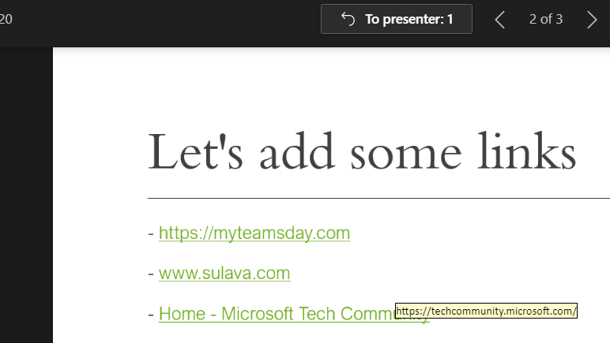

If you add a **online video**to your presentation your participants can activate that on their own as well. It is good also to note that if you hit “play” it doesn’t reflect to attendees (=they need to play the video themselves)

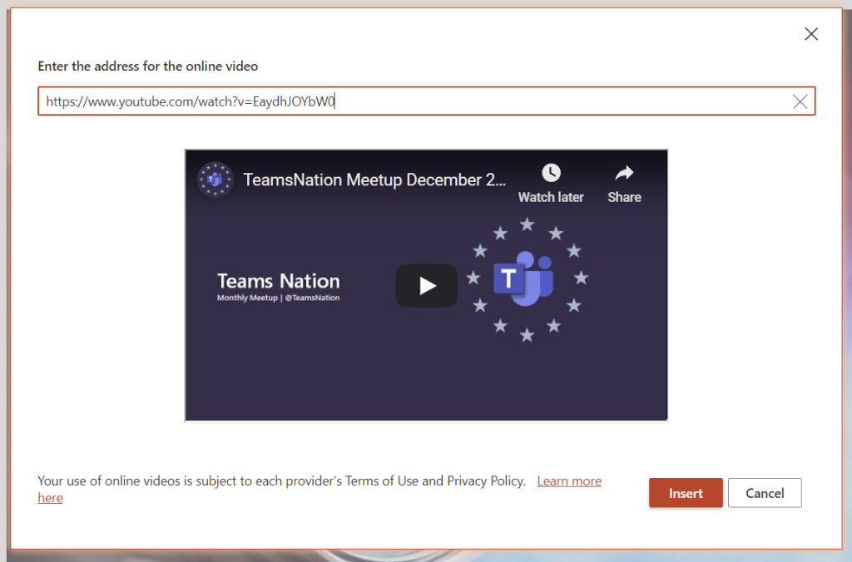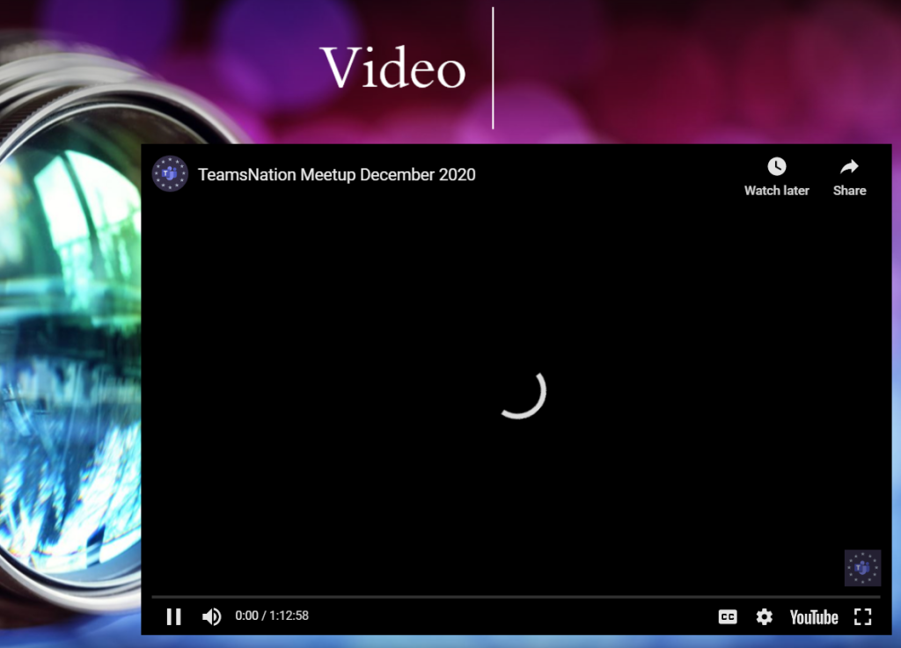

Teams Desktop: sharing a Whiteboard

When you choose Microsoft Whiteboard from the Share Tray you are taken directly to the Whiteboard view. Everyone who is in the same organization as you are (the situation in January 2021) can co-author the Whiteboard with you. Once you are done you can Stop presenting (middle top screen) or share something else.

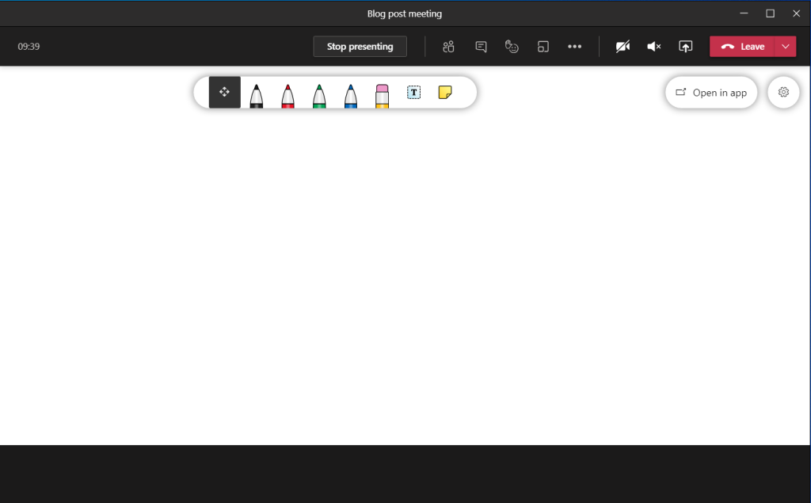

Teams web client: sharing a screen (Microsoft Edge)

Sharing looks a bit different when you are using Teams web client. Sharing is available in (new) Microsoft Edge and Google Chrome browsers. The toolbar is hovering on top of the meeting. From the toolbar you can open the share tray.



When you have the share tray open you can choose to share something of following

* Desktop (Screenshare)
* A specific PowerPoint document
* Whiteboard: either Microsoft Whiteboard or Freehand (3rd party).

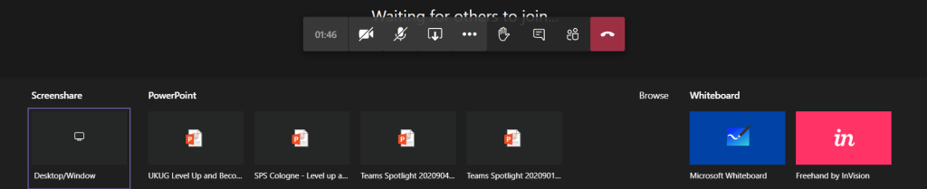Choosing a Screenshare you get to be more specific

* Entire screen
* Application window (a specific application only)
* With Microsoft Edge you have option to choose a selected, specific, tab

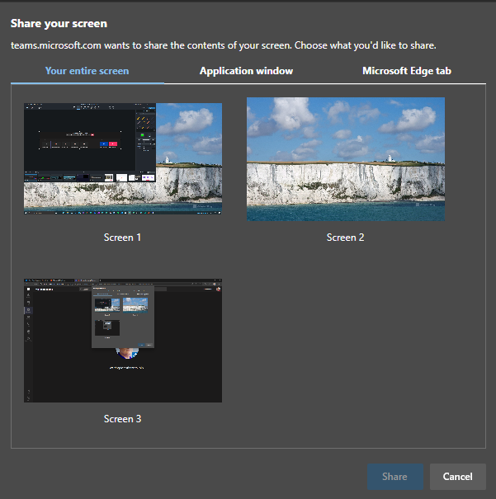

When(if) you have multiple monitors it is easiest to just share a one of them: it makes the sharing really simple and easy to manage: anything on that display is shared.

If you don’t have multiple monitors then you might want to just share a single application.

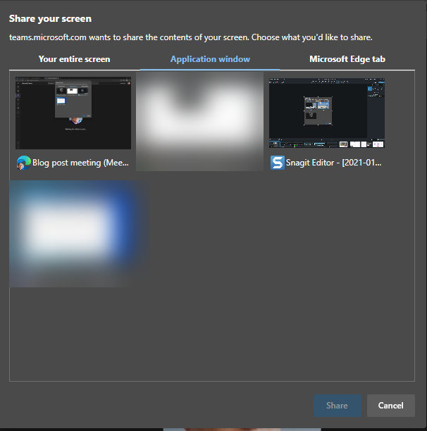

This is useful when you want to show something specific that runs in it’s own application but you can not share anything else on your screen.

Note: Teams is not in the list (not even on blurred ones) and nor is Spotify or ToDo. Not every application can be shared with this.

Note2: you can not share desktop audio to the meeting using Teams web client.

And the last option is to share a selected Edge tab – and if you have multiple Edge profiles open you can share from any of those by clicking the desired Edge active and choosing the tab.

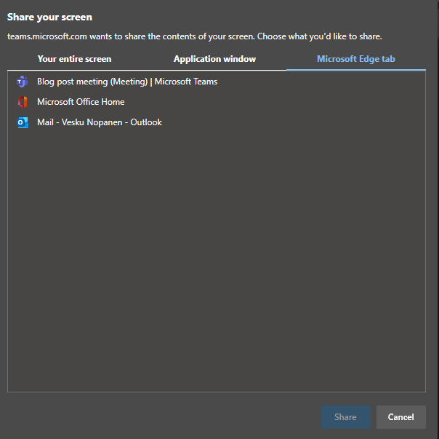

In my example I chose to share one of my screens. You don’t get much feedback – you just click on the screen and hit Share. In one of your screens you will have this toolbar:



You can end sharing using either that toolbar or you can navigate to your web Teams meeting and choose Stop sharing from the toolbar there.



Teams web client: sharing a PowerPoint

You can choose from your recent PowerPoint documents in the list

* A PowerPoint document you opened or edited in Microsoft Teams (in a team you belong to) or in your OneDrive

This list of sharing PowerPoints is causing often some big questions. PowerPoint presentations will be in the list once you edit or open the PowerPoint presentation in Teams or OneDrive (there may be some short delay). Generally it applies to the next meeting you join. Make sure you prepare for the meeting by opening the document in advance. Simply uploading a presentation to OneDrive or Teams does not bring it to the list – you need to open/edit it as well.

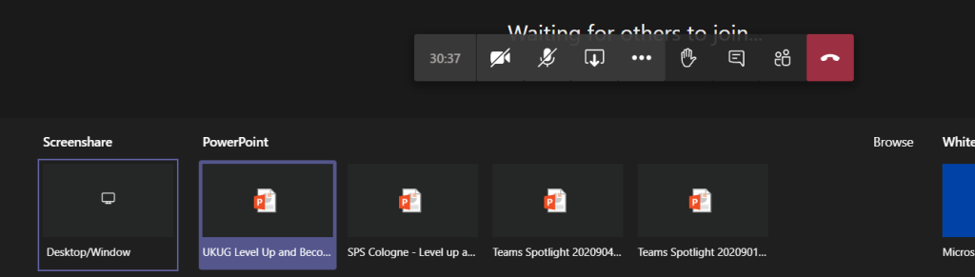

Once the presentation is shared you can move back and forth easily with arrows in the screen.

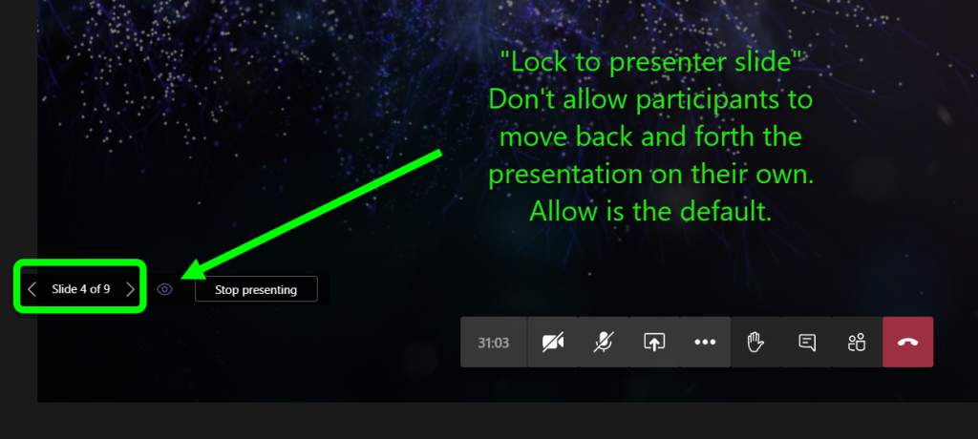

Note: there is the “eye” icon. If you press that one it locks the PowerPoint for the participants so that they see the same slide as you do: they can not browse the deck on their own. This is called private viewing disable. Private viewing is enabled on default.



Note: if you are a presenter in the meeting where a PowerPoint is shared to you can take control of the shared PowerPoint to advance slides. This does not ask for any confirmation and the feature is really useful when you have multiple presenters who use the same slide deck. Just be careful that everyone else are not presenters – or they know not to touch it.



You will get a warning that someone has taken the control and can easily take it back.



Whoever is in control of the presentation has also the control to disable/enable private viewing mode.

Teams web client: sharing a Whiteboard

Sharing a Whiteboard is initiated simply by choosing Microsoft Whiteboard (or Freehand or other available 3rd party application) from the share tray.

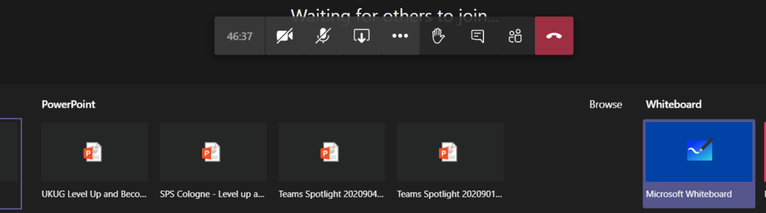

I have found out that sometimes when you start sharing Microsoft Whiteboard to the meeting using Teams web client it doesn’t do anything. **The solution is to try again.**

Once the Whiteboard opens you can work on it normally – or choose to open it in the Whiteboard app to have a broader set of tools available.

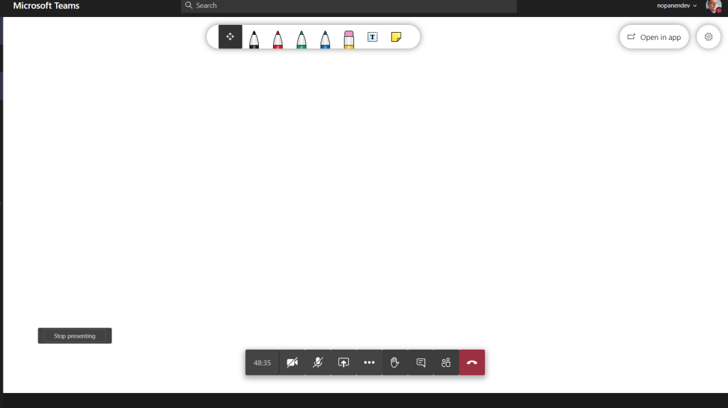

When you are done you can choose the “Stop presenting” that is hovering on the left bottom area (left of meeting toolbar).

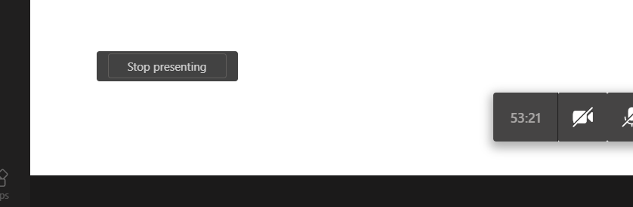

Teams mobile: sharing a screen

Were you aware that you can also share content using your mobile device? I have examples and screenshots using a Android device but these also work with iOS – the user interface might be slightly different.

You initiate the sharing via … menu selection in the mobile to open the list of options

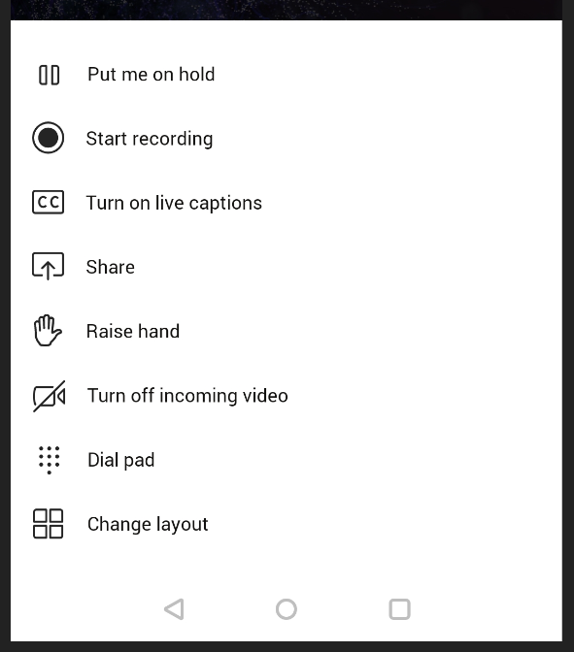

You choose Share and you get to choose what to share

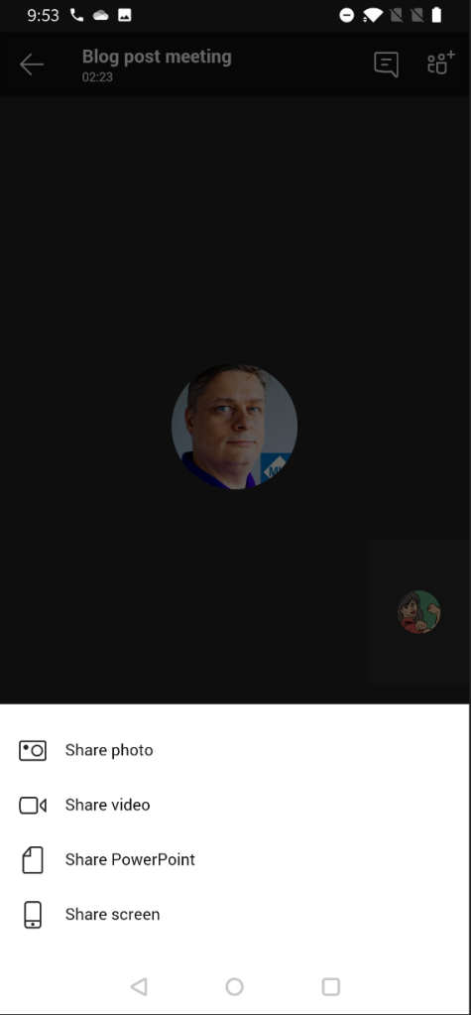

Yes – you can share your mobile device screen to the meeting. This is really useful if you have a application you want to show or train to others.

You may have to adjust settings to turn on allowing Teams to display over other apps.

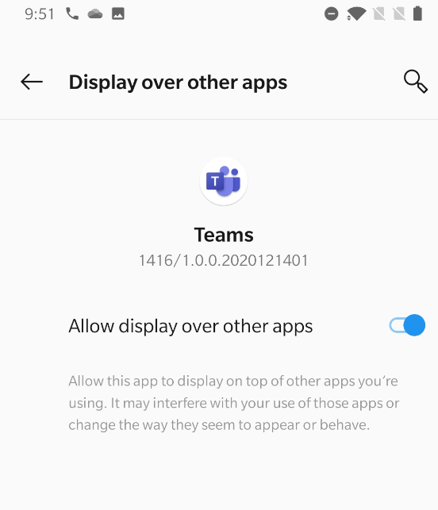

After that one you may have reshare the screen. And you get the next warning.

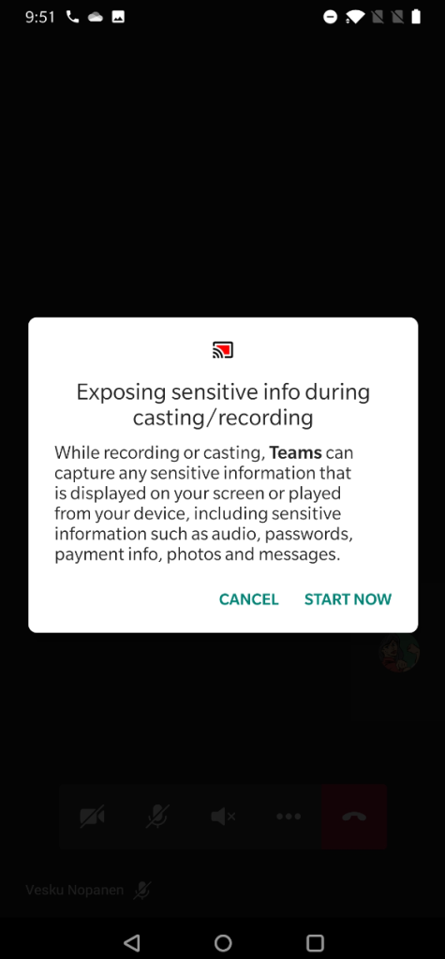

And your screen is now shared. You can see the red block that lets you know what are of your mobile device screen has been shared.

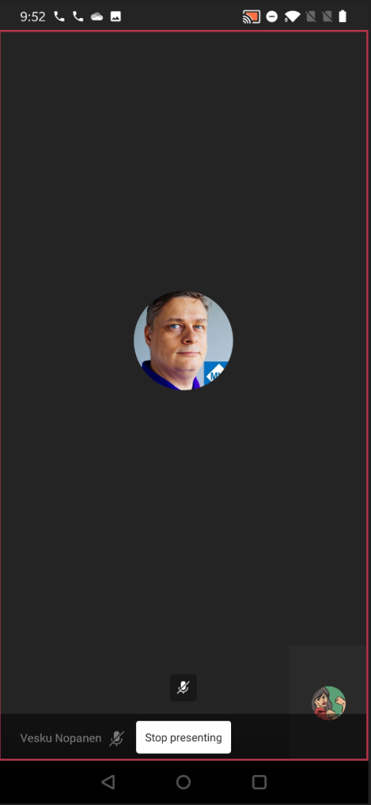

And if you pull down notifications area you have option to return to Teams meeting (if you have been using some other app) and there is also the notification that you are sharing your screen.

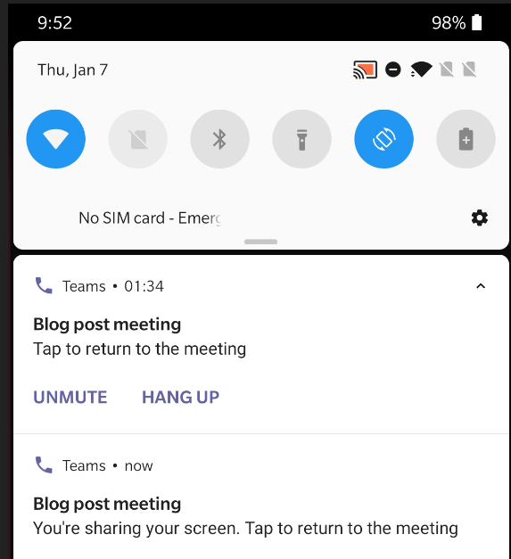

When you are done sharing you can return to Teams meeting and then choose to Stop presenting.

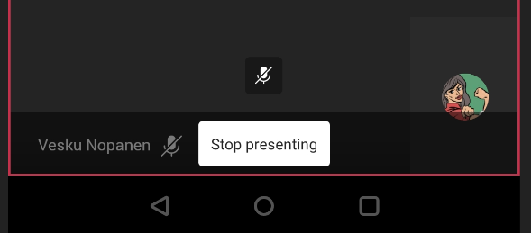

Teams mobile: sharing a PowerPoint

Sharing a PowerPoint works really well on Teams mobile! It is in fact even better than the version in other clients.

You start by imitating the sharing (as with screen share) and choosing the PowerPoint instead. You get a screen:

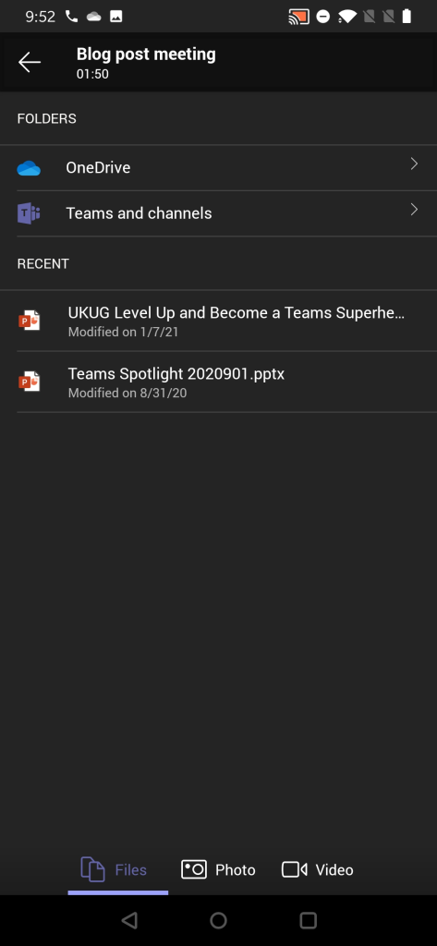

From this screen you can choose to browser thought

* OneDrive
* **A PowerPoint presentation from any Team and channel you belong to!**
* Choose a PowerPoint presentation you opened or edited most recently (as you notice compared to other examples that this isn’t 1:1 in sync.. There are differences so that is why I am really happy that you can browse through Teams for sharing)

Once you have selected the PowerPoint to present it is very straight forward from that moment.

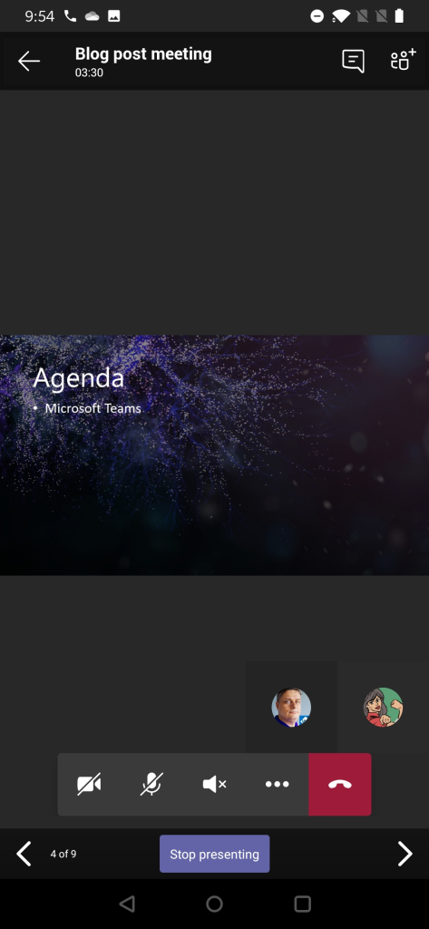

Using Teams mobile you can also take control of a PowerPoint someone else is presenting (if you are a presenter in the meeting). This means that you can participate in a multi-presenter meeting quite easily by using just your mobile device and Teams!



You will get a warning before you take the control – in case you pressed Take Control accidentally.

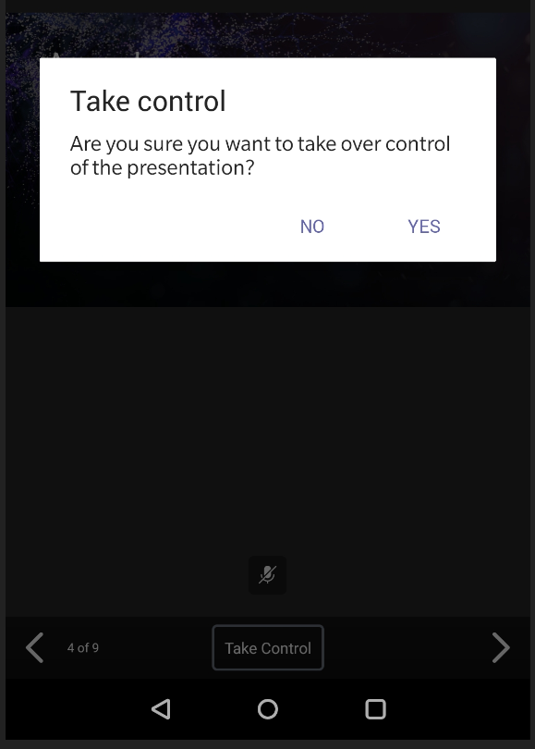

Teams mobile: sharing a photo or video

Follow the steps laid out earlier and instead of screen or PowerPoint you select this time a picture (from device’s picture gallery) or a video (using device’s video camera). Since sharing a picture is very straight forward I use the video instead as example.

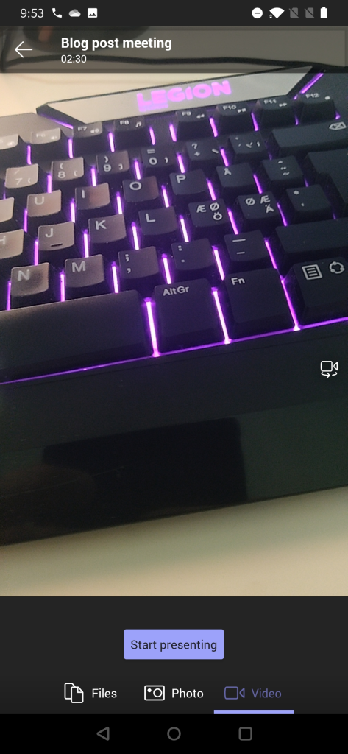

You get to see a preview of video first. You can switch to other camera (front/back usually) & position the device properly and once you are ready you just hit **Start presenting**.

And when you are done you can press on “Stop presenting” to end your video feed.

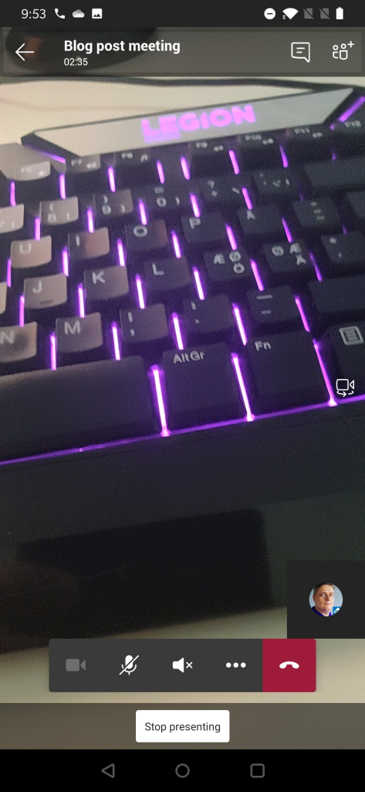

This video is different from showing your own video using Camera icon the meeting toolbar. Instead of being a attendee video this one is shown in the shared area for every participant in the meeting. This is useful when you have something in the same room/space that you want to share to others in the meeting. Possible use cases: a model on table, physical whiteboard, view from the window, interviewing someone, view in the outside, …

Best practices from my experience

The way I use to share content when in Microsoft Teams meetings is

* I share one of my screens (I have three screens so this is a natural choice for me). This way I know what is being shared all the time since I always share the same screen (the one in the middle, my camera is on top of that screen). Be careful what you drag to the shared screen. This is the way I share my PowerPoint presentations (projecting the presentation to the shared screen)
* If you have a touch-screen device (like Surface-laptop) you should use pen/inking to enhance the presentation experience. This also works when you are sharing the external screen & presenting from touch-screen device: make your presentation stand out!
* Prepare the content you share in advance. Open PowerPoints, apps, browsers etc so you don’t have to spend any time with them when you are live.
* Share your screen early rather than later. This will give you time to reshare.
* When doing a presentation with multiple persons using just the PowerPoint deck share it directly to Teams meeting so you can switch between speakers easily. With the new Presenter view -support this is now a good option.
* Make use of Teams features: Put everyone but real presenters else as attendee so they can’t start sharing their screen accidentally – and you can hard mute them as well. Use meeting options -setting before they join in.
* When people complain they don’t see the share: check that you are actually sharing your screen. If someone is seeing your share and some others not: those who can’t see your share need to leave and rejoin the meeting. Sometimes restarting your sharing can fix that issue too but usually the issue is in the participant end.
* I rarely use application / window -sharing.
* Sharing a video in Teams meeting (or in Live event) is usually ok but you can expect some quality drop – especially if you have a lower bandwidth. Have a backup link to the video available. People seem to struggle more with videos embedded inside a PowerPoint.
* Use Windows Focus Assist and Teams Do Not Disturb mode so you don’t get any unwanted popups on your shared screen. Microsoft Teams will also have a upcoming feature (currently usable in public preview) that let’s users to choose if Teams notifications do their own “toast” (pop-up banner) or do they go directly to Windows notification area (honoring the Focust Assist setting).
* Use Teams Desktop version + new meeting experience when possible. Check that you have the latest version.